**Explosion Particles and SFX**

**Objective**: Creating a simple explosion that will trigger some particles and also add a sound effect.

Warnings: If we have any warnings in our console we’re going to clear them up. They might be caused by scripts that we’re not using so let’s just delete them.

1. Lets rename our cube that we placed under the ship to **Landing Pad** and make it into a prefab.

**Particle System Component**

|  |  |  |
| --- | --- | --- |
| Particles |  | Particle System is a Component added to a Game Object |
| We use Modules for controlling behavior |
| Emitter |  | Each particle is not a Game Object |

1. Create an **Empty Game Object** and name it **Explosion**. Lets click **Add Component** and add a **Particle System** to this explosion**.**
2. Now lets see another way of adding a component. Now I have a file I can provide for you (SFX_Explosion_Simple) or you can go look for a sound effect that you want. From your assets folder drag and drop this sound effect file to the **Explosion game Object**

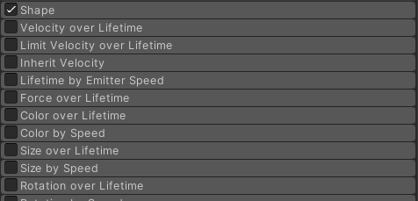The Particle System is a component that we add to a game object. We have the emitter, we have particles, and we use modules for controlling the behavior. So modules are, if we go to our ship where we have the bullets here, all these gray things, these tabs down here, these are modules. And it's important at this point for us to be really clear that each particle is not a game object. And the entire particle system is not a game object, it's a component that's added to a game object. he particle system is created to be super efficient. And so, it can push around thousands of things on this screen and not have our system come to a halt.

RECAP: PARTCILES ARE NOT GAME OBJECTS

1. Create an **Empty Game Object** and call it **Explosion**. Finally lets add a **Particle System component** to this game object**.**

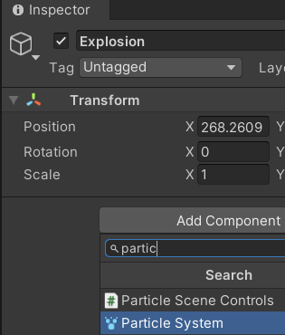

1. Im also going to create an **Audio Source** component to this **Explosion** Game Object. Im going to do this by dragging my **Explosion audio file** on to the **Explosion Game Object** in my Hierarchy.

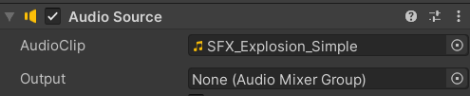

1. Im going to **lower the** **volume** for my audio source down to **0.25** bcause I know the file is too loud right now.

Let's go ahead and make our particle system a little bit nicer.

**Challenge:** The challenge is create an explosion effect, use the sphere shape under the shape module. I'd say have it last around about one second, and it's an explosion that comes and goes. And make it multi-colored, there's a new one for you. Find the color module and play around with that. And don't use the standard the default particle material, use one of the materials that I've given you in the previous lecture. [Particle System Main module](https://docs.unity3d.com/Manual/PartSysMainModule.html)

The point of that is to at least make SOMETHING. You got to practice.

1. Change **Duration to 0.5**  and **turn off Looping**.
2. Lets change **Start** **Lifetime** to **0.2** and **Start** **Speed** to **100**
3. Change the **Rate Over Time** to **300** and we should now have a whole bunch of particles.
4. Change the **Shape** to a **Sphere**
5. Lets go to the **Renderer Module** and change the **Material** to **Particle Square 1**

**COLOR**

In the past, we've looked at clicking on the color and just changing the color. This time we're going to do something a next step further, which is

1. click on **Start Color** n click onthe arrow thing to the right of Start Color, and choose **Gradient**. That'll allow us to do a gradient from a certain color to a certain color.

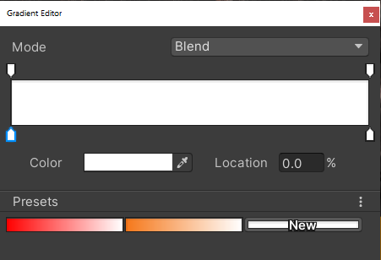

If you click on the little tab here, and that allows you to double-click on it, and bring up the color thingy.

So if we say, this is red, and we've leave that up white, then the particles coming out. I'll change the **Playback Speed** to 0.1 so that we can see, I'll turn off looping. They're coming out red, red, red, nearly red white, white, and then white at the end.

And so, basically, as the particle system plays, it's going to play this color, this color, this color, this color, this color all the way down to white for the final particles that come out.

1. Lets add a bit more color to this. Go back to the Color menu and click below the continuum to add more tabs. I ended up going: Red, Orange, Yellow, Orange, and Red

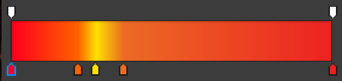

1. To create this as a present **click on the NEW button** at the bottom. That will save what we just created as a preset so that we can use it in the future.

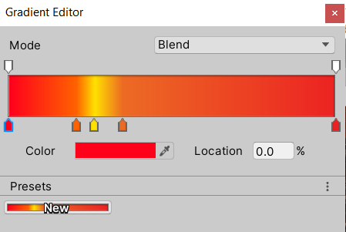

1. Right now the colors are blending by we can change the mode to FIXED and it will have colors of fixed length. I left mine in Blend mode cause i liked it better.

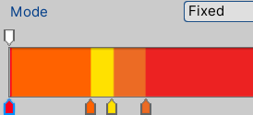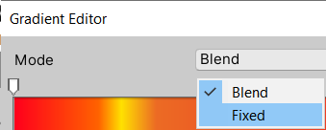

1. I’m going to change the start speed since its coming out pretty fast. I want to add some variation so click on the arrow next to **Start Speed** and I’m going to choose **Random Between Two Constants**. What this means is each particle will have a random speed from 5 to 100.

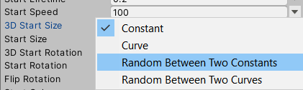

Change the **Start Speed** values to 5 – 50 and click play on the Particles.

1. We’re going to do the same thing with the size of the particles. Click on the arrow next to **Start Size** and choose Random Between Two Constants. Set the range from **1 to 2**.

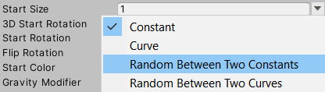

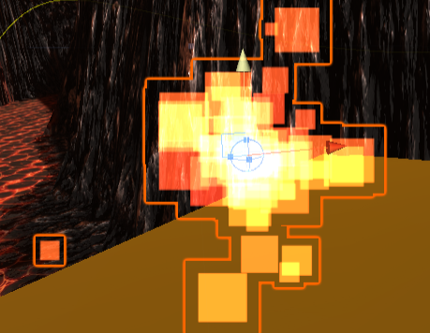If you want to create a more blurry look change the range to 1-5. I ended up choosing this route cause I really liked how my explosion looked.

1. Last thing is I’m going to **turn off** **Play on Awake** because we don't want this to be triggering as soon as our game starts.
2. Also **change Simulation Space to World.**